**Module (HTML5) – 3**

1. **What are the new tags added in HTML5?**

**Ans.**

HTML5 introduced several new elements and attributes to improve the structure of web documents. Some of the notable new tags added in HTML5 include:

* **<header>:** Defines a container for introductory content or a set of navigational links.
* **<nav>:** Represents a section of a page containing navigation links.
* **<main>:** Indicates the main content of the document. There should be only one <main> element in a page.
* **<article>:** Represents a self-contained composition, such as a blog post or news article.
* **<section>:** Groups related content together and can be used to define chapters or subsections in a document.
* **<aside>:** Represents content that is tangentially related to the content around it. It's often used for sidebars, pull quotes, or advertising.
* **<figure>:** Used to encapsulate a media object, such as an image, video, or diagram, along with its caption using the <figcaption> element.
* **<figcaption>:** Provides a caption or description for a <figure> element.
* **<footer>:** Defines the footer of a section or a page, typically containing copyright information, contact details, or other metadata.
* **<mark>:** Highlights text within a document, usually by applying a yellow background.
* **<time>:** Represents a specific period or point in time, such as a date, time, or duration.
* **<details>:** Provides a disclosure widget to show or hide additional information, often used in conjunction with the <summary> element.
* **<summary>:** Used in combination with the <details> element to provide a summary or title for the hidden content.
* **<datalist>:** Contains a list of predefined options for an <input> element with a list attribute. It allows for auto completion in form fields.
* **<output>:** Displays the result of a calculation or user interaction.
* **<canvas>:** Provides a container for graphics and animations, allowing you to draw and manipulate images using JavaScript.

1. **How to embed audio and video in a web page?**

**Ans.** To embed audio and video in a webpage, HTML5 provides the <audio> and <video> elements. Here's a Details:

**Embedding Audio:**

Use the **<audio>** tag to embed audio in your webpage.

**Example:**

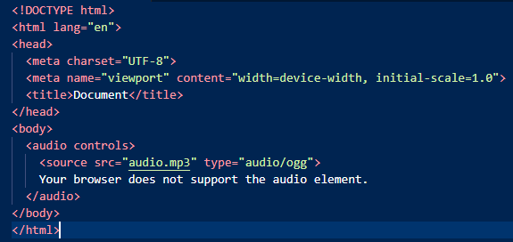

The controls attribute displays standard audio controls (play, pause, volume, etc.).

The **<source>** tag within **<audio>** specifies the audio file and its type (MP3 in this case). You can include multiple **<source>** tags with different file formats to enhance browser compatibility.

The text within the **<audio>** tags serves as a fallback message for browsers that don't support the **<audio>** element.

**Embedding Video:**

Use the <video> tag to embed video content in your webpage.

**Example:**

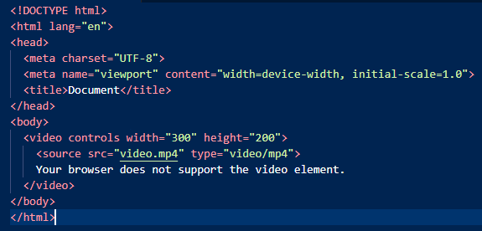

The controls attribute displays video playback controls.

You can set the **‘width’** and **‘height’** attributes to define the video's dimensions.

Just like with **<audio>**, use the **<source>** tag to specify the video file and its type. Provide multiple sources for different formats for broader browser compatibility.

**Additional Attributes:**

**Autoplay:** Use the autoplay attribute (**<audio autoplay>** or **<video autoplay>**) to make the media start playing automatically when the page loads.

**Looping:** Use the loop attribute (**<audio loop>** or **<video loop>**) to make the media content continuously loop.

1. **Semantic element in HTML5?**

**Ans.** In HTML5, semantic elements are HTML elements that carry meaning about the structure and content of a web page. These elements help to describe the type of content they contain, making the document's structure more understandable for both browsers and humans. Using semantic elements improves accessibility, search engine optimization, and the overall organization of a webpage.

**Here are some of the key semantic elements introduced in HTML5:**

* **<header>**
* **<nav>**
* **<main>**
* **<articale>**
* **<section>**
* **<aside>**
* **<footer>**
* **<figure>**
* **<details>**
* **<mark>**
* **<time>**

Using these semantic elements correctly in your HTML documents makes it easier for search engines, screen readers, and other user agents to understand and interpret the content, improving the overall accessibility and user experience of your website.

1. **Canvas and SVG tags.**

**Ans.**

HTML5 introduced both the **<canvas>** and SVG (**<svg>**) tags, which are used for rendering graphics in web pages, but they have different approaches and use cases.

**<canvas> Tag:**

The **<canvas>** element is an HTML tag that provides a drawable region on a webpage using JavaScript. It's a bitmap-based system that allows drawing graphics, animations, and images dynamically. It doesn't provide built-in shapes or structures; instead, it's a blank slate where JavaScript is used to draw and manipulate pixels.

**Input Output**

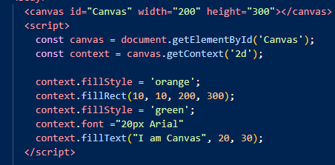

**<svg> Tag (Scalable Vector Graphics):**

The <svg> element is an XML-based language for creating vector graphics in HTML. It allows the creation of scalable and responsive graphics and images. SVG uses XML syntax to define shapes, text, and images, making it easy to create and manipulate various graphical elements.

**Example:**

**Input: Output:**

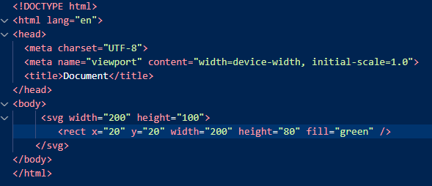

In this example, a Green rectangle is created within an SVG element. The attributes like **x, y,** **width, height,** and **fill** define the shape's properties.

Both **<canvas>** and **<svg>** have their own advantages and best-use scenarios. Canvas is generally preferred for dynamic or pixel-based animations, while SVG is often used for static or scalable graphics. The choice between them depends on the specific needs of project.